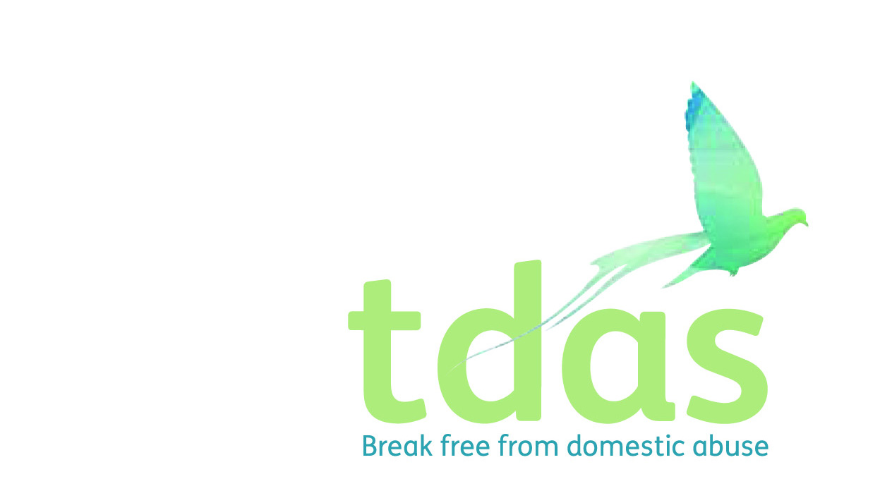

|  |  |
| --- | --- |
| **Title:** | Male CYP Trafford Volunteer |
| **Area:** | CYP Trafford |
| **Reporting to:** | CYP Team Leader |
| **Place of work:** | Trafford |
| **Hours of Work** | TBC |
| **Salary/scale:** | Voluntary |
| **Benefits:** | NA |
| **Closing Date** | NA |
| **Date of Interview \*\*** | NA |
| **Start Date** | NA |

*This post is subject to DBS disclosure scheme and there is an Occupational Requirement under the Equality Act 2010 Schedule 9 (Part 1) for the post holder to be a man.*

**Background**

Trafford Domestic Abuse Services (TDAS) is a registered charity offering support to individuals and families living or working in the Trafford area who are suffering or who have suffered domestic abuse. We provide both intervention and prevention services and work in partnership with other voluntary organisations to support families across Greater Manchester.

**TDAS Values**

**I**nnovative: introduce new ideas, are creative and foreword thinking.

**C**ollaborative: work in partnership with key stakeholders to enable people to achieve a defined & common purpose

**O**penness: create an open culture, provide transparent reporting, good fundraising and governance.

**P**erson centred: provide coordinated, personalized and enabling services to everyone

**E**mpowering: empower our service users to become stronger, more confident, being aware of their rights and privileges and live a more meaningful and fulfilling life.

**Purpose of the role**

To support and contribute to all aspects of Children and Young People’s teams. Support staff to deliver our specialist Children and Young People’s projects in the community to a group of children who have or currently are living with domestic abuse and suffering the traumatic effects of such. To also support staff to deliver a targeted prevention project to young males in the community.

**Main duties**

* Access, organise and deliver the appropriate trauma informed services to meet the needs of the children/young people and their families
* Organise and facilitate TDAS R’Space programme and Evolve Workshop
* Deliver Healthy Relationship Workshops to young people in high school and community settings
* To keep individual recordings which are factual, accurate and up to date of the CYP who attend programmes
* To obtain, record and report outcomes for the service through the use of attendance sheets, evaluation forms and observations
* To complete internal referrals to other areas of the CYP support service to meet the needs of the CYP
* Access regular feedback from service users to ensure the continued improvement of services and support offered to CYP by TDAS
* Provide an environment for CYP in which their physical, emotional, intellectual and social wellbeing is promoted
* To be aware of, implement and keep up to date with Child Protection/Safeguarding Procedures in accordance with TDAS and Trafford Safeguarding Partnership policies and procedures
* Provide a welcoming, safe, stimulating and inclusive environment in which CYP can be supported, enjoy themselves, develop to their full potential and meet with the requirements of Every Child Matters and current legislation
* Promote an inclusive environment that meets the differing needs of all CYP.

# Experience/ Knowledge/ Qualifications

* Experience working with children and young people would be beneficial, however training will be provided
* Experience delivering workshops and presentations would be beneficial, however training will be provided
* Excellent communication and interpersonal skills
* Strong relationship-building abilities
* Ability to work independently and as part of a team
* Proficient in Microsoft Office Suite
* Positive commitment to Equality and Diversity
* Approachable, reliable, trustworthy
* Good IT skills
* A general understanding of domestic abuse, its effects on the victims, their families and the wider community
* A commitment to TDAS Values
* Clear understanding of confidentiality and an awareness of GDPR

**Supervision**

* This volunteering role is subject to receiving satisfactory references and may require an enhanced DBS check.
* Volunteers are responsible to the Children and Young People’s Team Leader and Volunteer Manager
* Volunteers are to ensure that all organisational policies and procedures are followed and adhered to appropriately.
* Volunteers are expected to follow reporting procedures outlined by the Children and Young People’s Team Leader and in line with Policy and Procedure; this applies to all concerns, incidents and anything relating to Adult and Child Protection/Safeguarding.
* Volunteers are expected to attend regular supervision meetings with the Children and Young People’s team leader.
* The health and safety of volunteers, staff and service users is paramount, and it is essential that volunteers take accountability of this when undertaking this role

**Benefits**

* Volunteers will be offered training, which is relevant to the volunteering role, which will be provided by the organisation. This may be in house training or through an external organisation.
* Travel expenses will be reimbursed (within reason and agreed with the Children and Young People’s Team Leader)
* Ongoing personal development and training will be supported, encouraged and facilitated where possible
* The opportunity to make a real difference to those who use our services.
* Gain valuable experience in fundraising
* Contribute to a supportive and rewarding work environment
* Expand your professional network and enhance your career prospects

# Additional Information

# We are committed to creating an inclusive and diverse workplace where everyone feels valued and respected. We encourage applications from people of all backgrounds, regardless of their race, ethnicity, gender, sexual orientation, religion, or disability.

**How to apply**

* If you are interested in applying for this volunteering role, please complete the Volunteer Application form on our website and return to: [admin@tdas.org.uk](mailto:admin@tdas.org.uk)
* If you have any questions or would like to discuss this opportunity further, please feel free to call the office on 0161 872 7368.

*This post is subject to DBS disclosure scheme and there is an Occupational Requirement under the Equality Act 2010 Schedule 9 (Part 1) for the post holder to be male.*